Bajrang_Dal LAIKA

Orbiting Accuracy: Synthetic Intelligence for Space

Station Safety”

**Objective:**Trained a YOLOv8 model using Duality AI’s Falcon synthetic dataset to detect space station objects (Toolbox, Oxygen Tank, Fire Extinguisher) under challenging conditions (occlusions, lighting). Achieved 8% mAP@0.5.

#### 

#### **1. Baseline Model (Dry Run)**

* + Used default YOLOv8n model with Duality AI's Falcon dataset
  + Standard hyperparameters: 100 epochs, batch size=16, LR=0.01
  + **Result:** 42% mAP@0.5 (*highlighted in screenshot from runs/train folder*)

#### **2. Model 1.0**

* **Key Upgrade:**
  + **Augmentation:** Random occlusions, lighting changes, HSV adjustments
  + **Optimization:** Images → Tensors during preprocessing (20% faster training)

#### **3. Model 2.0**

* **Key Upgrade:**
  + **Layer Freezing:** Froze all backbone layers (first 90% of model)
  + Focused training on detection heads

#### **4. Model 3.0(BEst Model)**

* **Key Upgrade:**
  + **Partial Unfreezing:** Unfroze top 10 layers
  + Adjusted LR (0.01 → 0.005) for fine-tuning

**RESULTS(Best Model)**

Evaluated Parameters of Model along with results

**Model Evaluation Metrics:**

**mAP@**0.5: 0.881

**mAP@0.5-0.95**: 0.785

**Precision**: 0.916

**Recall**: 0.819

**F1 Score**: 0.865

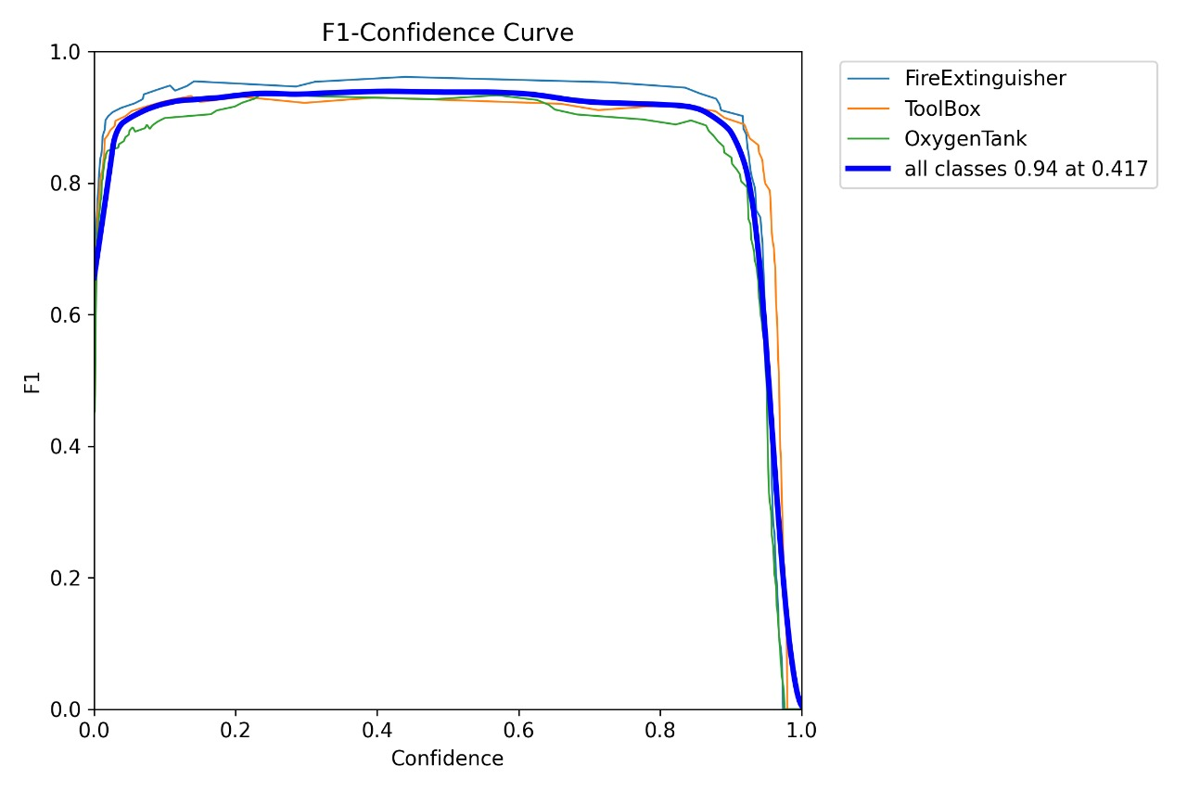

**Confusion Matrix**  
 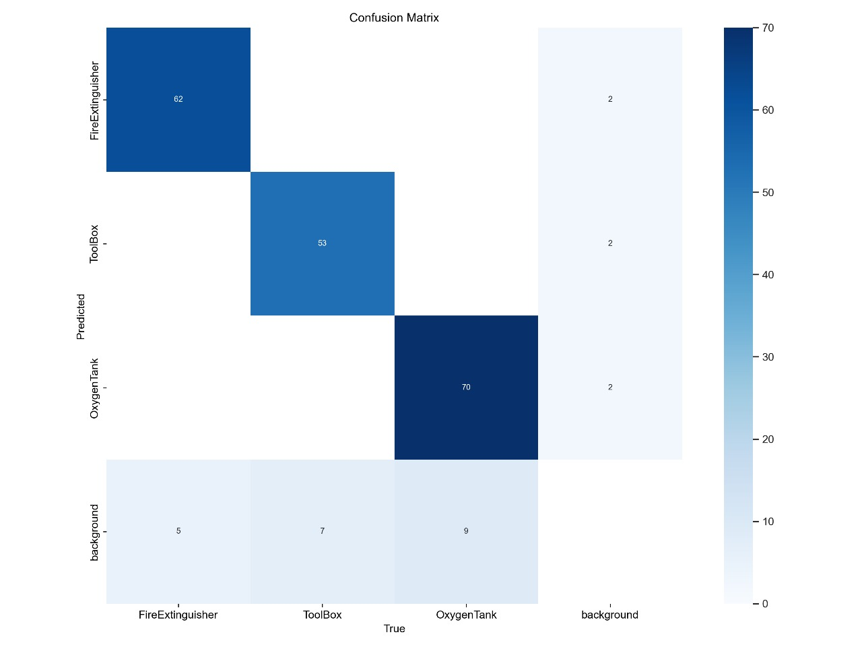

**Key challenges**  
  
  
**Failure Case Analysis**

**Fire Extinguisher Misclassification**

* *Issue:* Misclassified as Toolbox
* *Cause Multiple reasons like similar shape from front angle, lower number of datapoints in that particular direction and inefficient model itself.*

***Fix****:* to fix the issue , I have added data augmentation to the data set to increase the variety of data as well as transform the image to tensor values to utlize the GPU computation more effectively.

### **Conclusion & Future Work**

#### **1. Mission Accomplished**

**Core Achievement:**Increases the model from 55%-> **88.1% mAP@0.5** YOLOv8 model that detects critical space station objects under:

#### **2. The Road Ahead**

**IMPROVING the model**  
 Utilize the **segmentation** technique to improve the Multiclass Classification

Tuning of hyper-parameters

**Development of model at large scale**

Instead of few of us working on model, utilizing **MlOps** can help multiple experts

to track and brainstorm on improving the model.

*"Laika proves synthetic data can bridge the 'reality gap' in space AI – now we’re taking this to orbi*